ANISAH BINTI HANAPI
A-03-20
Pangsapuri Sri Aman
Jalan Puchong
Taman Puchong Prima 47150
Puchong Selangor

anisahhanapi@gmail.com

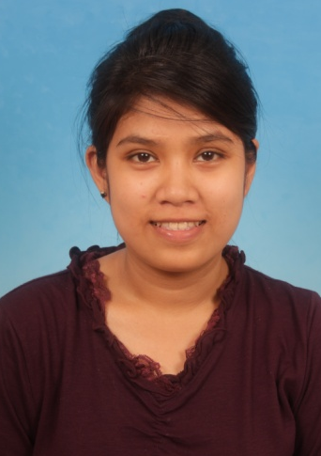

- PERSONAL DETAIL

Date of Birth : 19 November 1992
Place of Birth : Kg. Mempakat, Sabah
Age : 21
Marital Status : Single
Sex : Female
Nationality : Malaysian
Religion : Islam
IC Number : 921119-12-5078
Phone Number : 011-26116256

- EDUCATION

Tertiary Education : September, 2013
Diploma in Hospitality Management
Malaysian Academic & Skills Advancement

Secondary Education : December, 2009
Sijil Pelajaran Malaysia Vokasional (SPM)
Sekolah Menengah Kebangsaan Jenjarom

December, 2007
Penilaian Menengah Rendah (PMR)
Sekolah Menengah Kebangsaan Jenjarom

- SPECIAL SKILLS

Language Proficiency

Spoken Language : English, Bahasa Melayu
Written Language : English, Bahasa Melayu

Computer Skills

Microsoft Office

- STRENGTH

  - Aggressive with high personal and career goals
  - Committed and work towards deadlines
  - Able to perform under pressure and proactive; and work independently with minimum supervision
  - Fast learner, willing to learn and improve my knowledge & professional skills
  - Possess good computer literate skills

- WORKING EXPERIENCE

Grand Lexis practical training
Hospitality (Hotel) 2013
Task:
- Housekeeping
- Answer call
- Make calls
- Taking orders
- Greet the guests
- Chinese set banquet
- Dome set banquet
- Able to serve guests in style of Chinese Set, Dome, Buffet, Western, Kiosk,
- Cashiering
- Setup table, bed, and bathroom
- Opening and closing store
- Petty cash money
- Serve costumers
- Assist guest
- Handle float money
- Buzzing
- Handle complaint

Watson’s Personal Care Cashier
Customer service 2011-2012
Task:
- Handling petty cash
- Serve customer
- Monitor item in store
- Cashiering
- Greet the guests
- Assist customer
- Recommendation of product
- Opening and closing store
- Count stock on hand
- Stocktake
- Update price tag
- Housekeeping
- Transfer excess money
- Handle float money
- Handle complaint

Convex KLCC Partime Waiter
Banquate 2011-2012 Task:
- Able to serve guests in style of Chinese Set, Dome, Buffet, Western, Kiosk,
- Able to use and recognized cutleries and ware efficiently
- Able to serve guests in sequence with minimal supervision
- Able to serve fish dish with correct method of cutting and serving
- Able to recognized well dishes and beverages, sequences, and type of beverages
- Greet and seat the guests continue serving until finish dessert
- Clear table / closing
- Set up table
- Fold napkin
- Buzzing
- Handle complaint

Sunway’s Hotel Resort and Spa Partime Waiter
Banquate 2010-2012
Task:
- Able to serve guests in style of Chinese Set, Dome, Buffet, Western, Kiosk,
- Able to use and recognized cutleries and ware efficiently
- Able to serve guests in sequence with minimal supervision
- Able to serve fish dish with correct method of cutting and serving
- Able to recognized well dishes and beverages, sequences, and type of beverages
- Greet and seat the guests continue serving until finish dessert
- Clear table / closing
- Set up table
- Fold napkin
- Buzzing
- Handle complaint

- CAREER OBJECTIVE

To be able to contribute significantly in the company’s growth and development, at the same time secure a reasonable chance for further promotion opportunities.

- CAREER AMBITION

Be a successful in any task given and compete with others employee to be the best.

Current salary : RM 200 (practical allowance)
Expected salary : RM 1500 (Negotiable)
Data available for employment : One month notice required

- REFERENCES

Mrs Wan Nuridayusmi binti Wan Sulaiman
Head Of Faculty of Diploma Hospitality Management
Malaysian Academic & Skills Advancement (MASA) College
Phone No. 019-6717232

Mr. Muhammad Fadzil Ahmad Ahmad
Restaurant Manager Food and Beverage
Grand Lexis
Phone No. 017-360 2348

Mrs Fadzlina binti Ismail
Store Manager
Watson’s Personal Care Store
Phone No. 017-2043385
Mr. Vasudevank
Event Coordinator
Sunway Resort Hotel & Spa
Persiaran Lagoon, Bandar Sunway, 46150,
Petaling Jaya, Selangor Darul Ehsan, Malaysia.
6019-2668526 / 60 3 7492 8000

Mohd Zaharullah bin Mohammed Zafarullah
Human Resource Supervisor
Convex Malaysia Sdn Bhd.
Kuala Lumpur City Centre.
+6017-3756790 / +603-23332807

